**Weather & News Updates site using type script and expo**

Description:

This React Native application allows users to get the current weather and top news updates. The weather is fetched from the OpenWeatherMap API, while the news articles are fetched from the News API. The app enables users to enter a country to get the respective weather data, including temperature, humidity, and condition. Additionally, it shows top headlines of the world. Run the application going in the terminal to NewsApp directory and use npx expo start.

Fig 1:

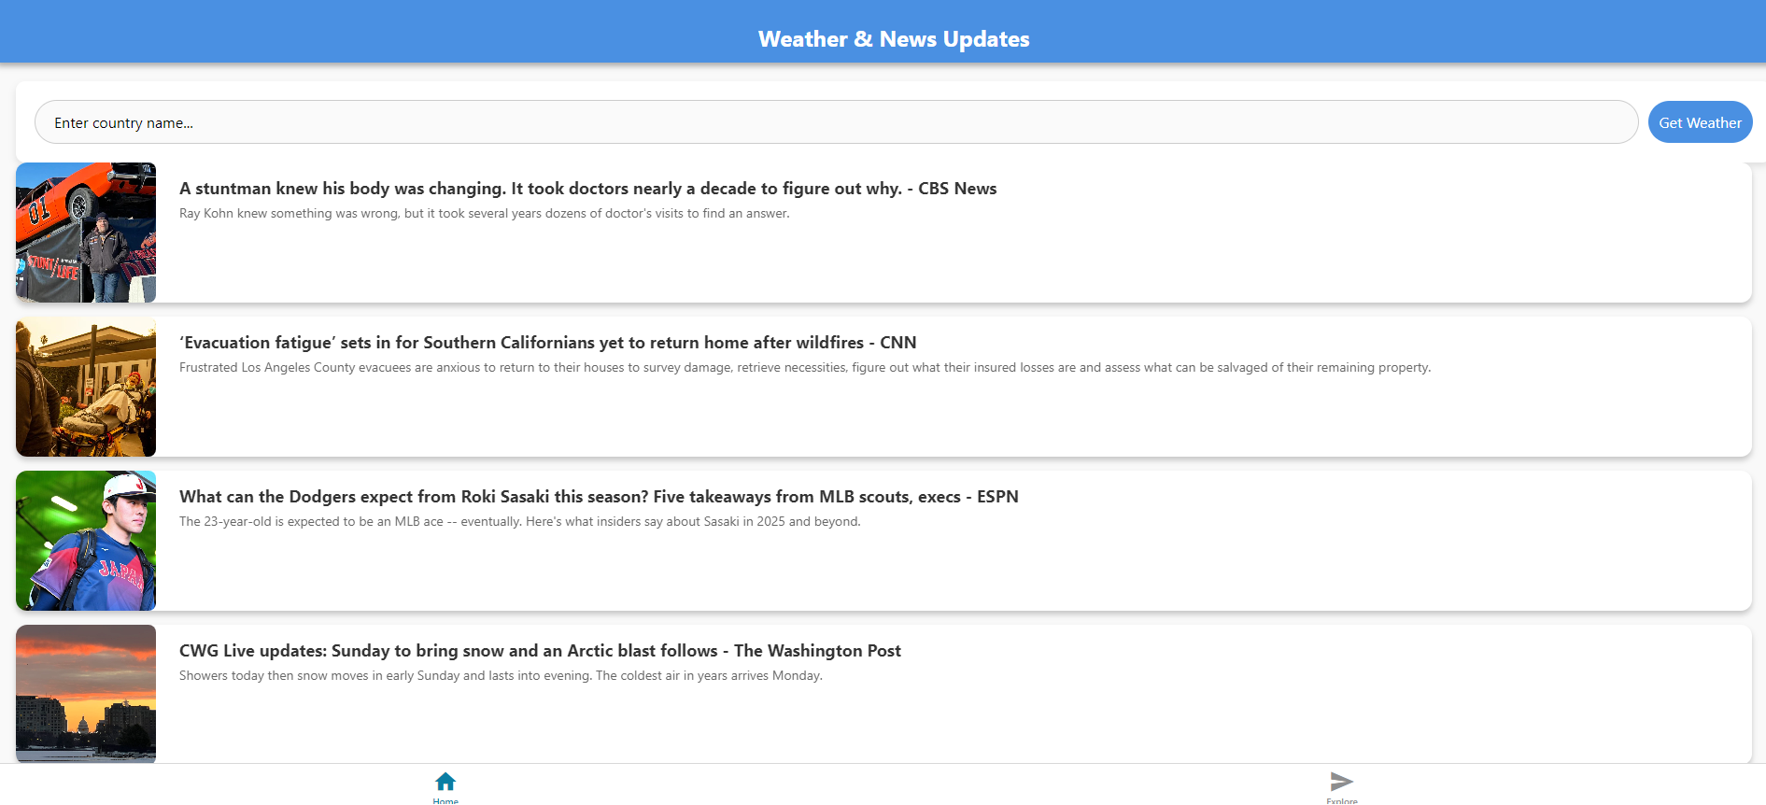

Fig 2:

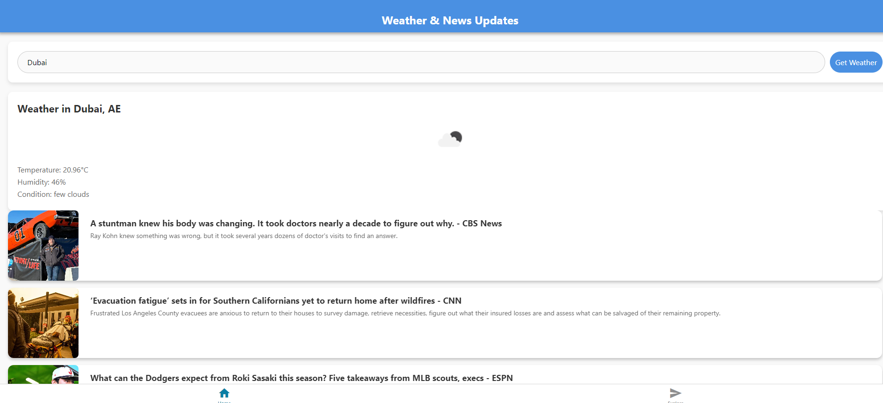

Fig 3:

